Go to xr4000_galil
Then use
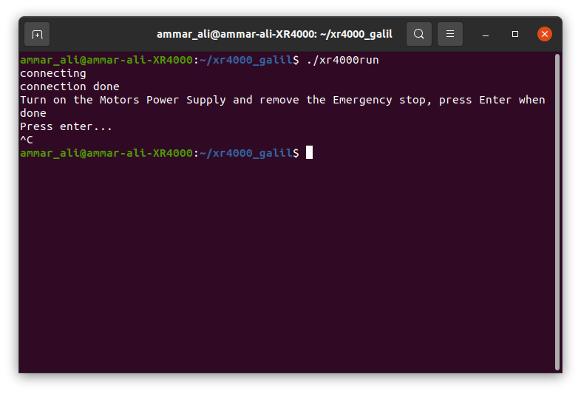
follow the instructions to initialise

for the joystick
go to

ammar_ali@ammar-ali-XR4000:~/xr4000_joystick/xr4000_joy$
then
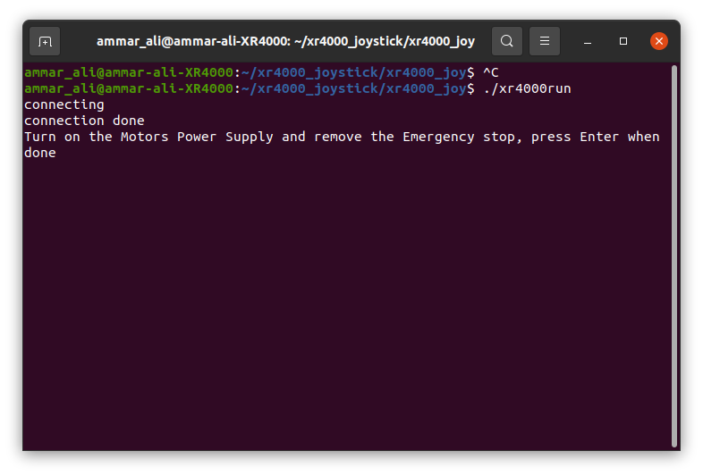

when the code run you need to press the joy stick button to activate the robot.
Note that the robot has circuit breaker for the motors power supply and it has emergence stop.
The circuit breaker should be on and the Emergencey stop is off to make the robot move.

